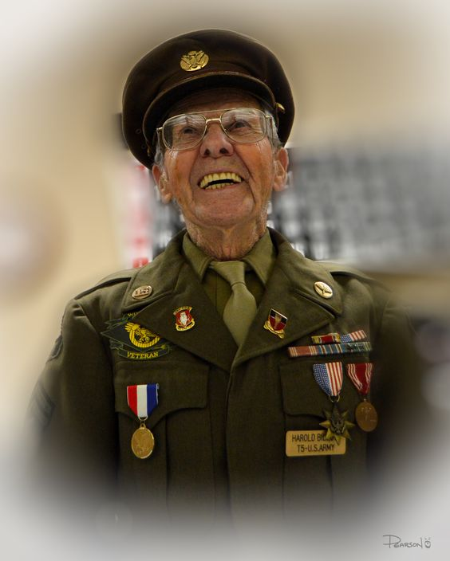
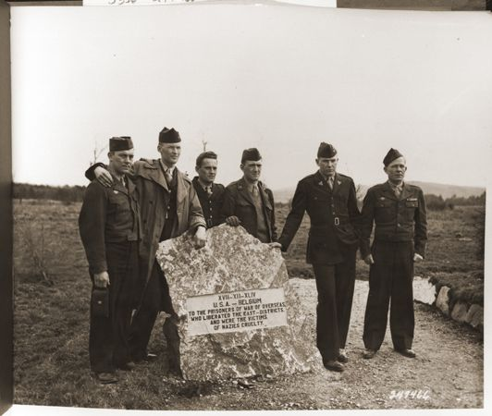
HAROLD BILLOW
U.S. SOLDIER
&
SURVIVOR

TRAINING AND EARLY WAR
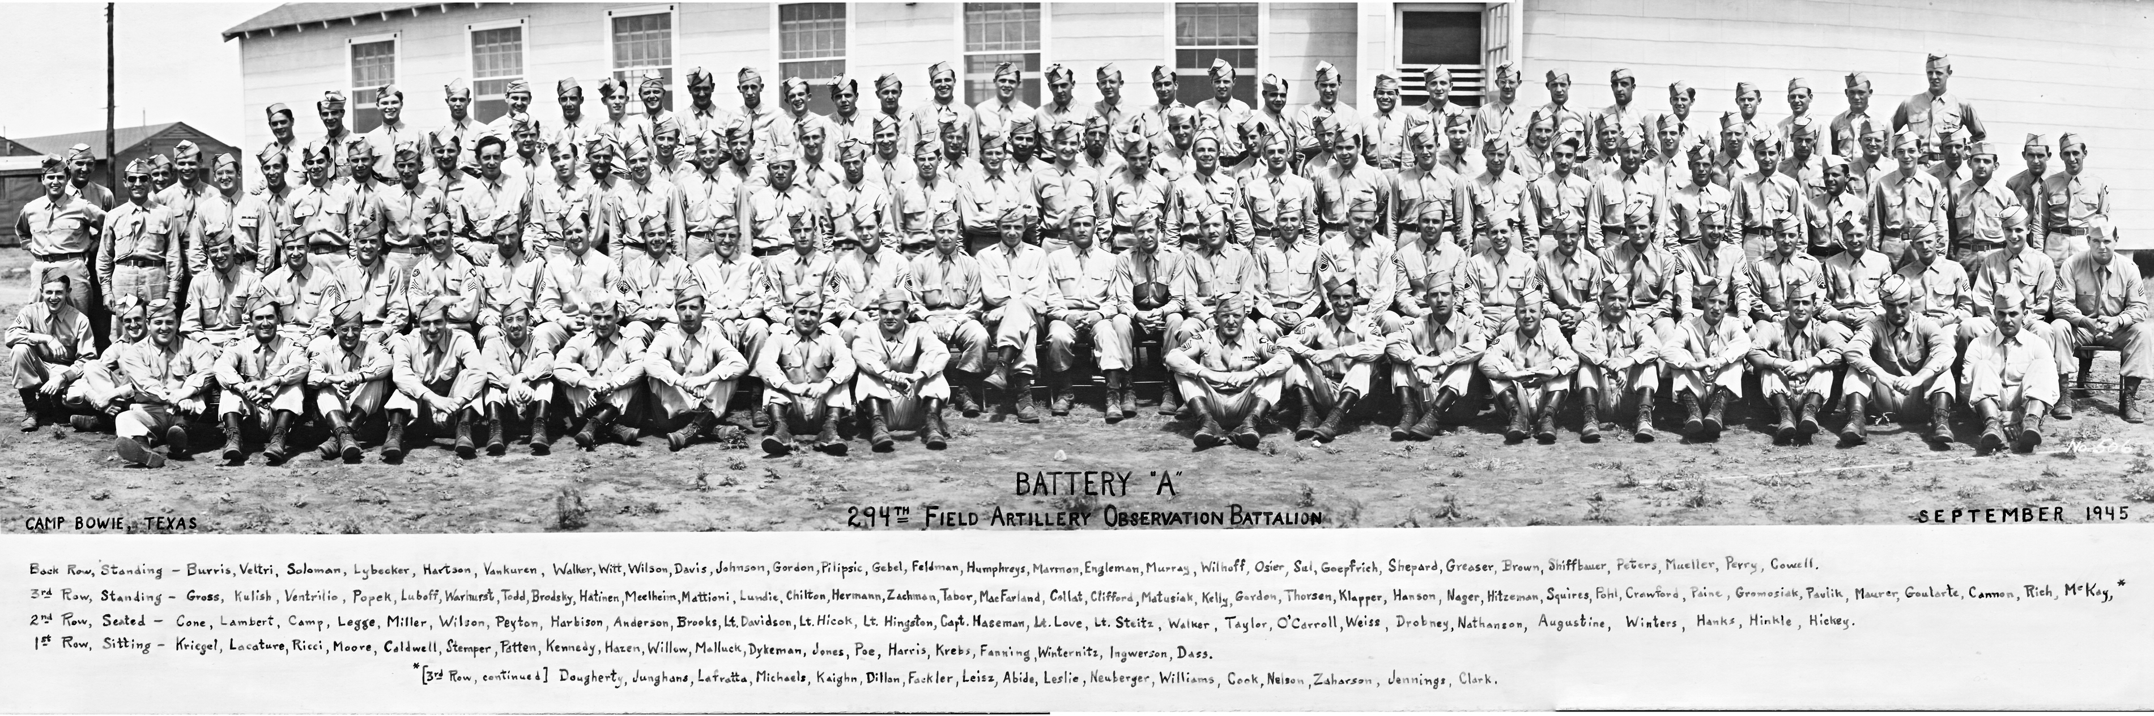
“I was drafted in 1943, and went to Camp Gruber Oklahoma for basic Training. I then went to Camp Polk LA for manuvers training, then I was sent back to Oklahoma to Fort Sill. Here we trained officers for oberservation battalion, I was there for a year, thenI was shipped to Camp Shanks NY. I got on a ship that took us out and we ended up in Wales, England, on the way one ship got torpedoed. Then we were in England for some time, we did not hit the beaches of Normandy on D-Day, however we reached Omaha beach in August. I was a part of the observation battalion so I would pick up the sound of enemy gunfire, they I was sent to the front lines to set up observation posts, as the lines moved so did we. On December 17 we were given the order to go to St. Vith, we never got there”

THE MALMEDAY MASSACRE
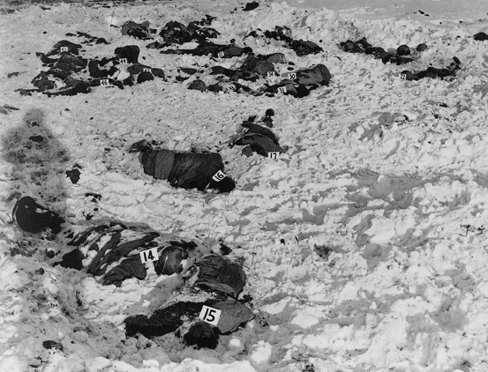
“We got into what allies called Malmedy Massacre, the german Panzers came from the left they shot up the vehicles the whole column stopped. The Germans forced them off the road I was one of the last in the convoy. The Germans marched us into a field off the road Panzer tanks confronted the allies, they set up two MG-42's on this tank. A German officer arrived, Peiper and killed two of our soldiers, the officer then orders the machine guns to wipe out the American prisoners the 150 americans in the field. The Germans were not supposed to take prisoners at that time they hd no time for it. Some soldiers asked their officers what to do, the officer ordered the soldiers to shoot after the machine gun stopped, the Germans walked through the field, anyone who was alive they shot them in the head, I waited in the field and played dead the Germans shot the field some more even after that after a while One American said “c'mon guys lets get out of here”all that were able to walk did so, including me, we then ran towards friendly territory.”

TALES OF HORROR
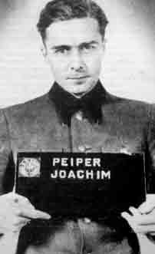
“At that point no American had heard about the Holocaust, I only heard about a church massacre by the Germans. I heard of a German officer called the Blow-Torch It was the same guy as Malmeday, Pieper, I never thought they would kill everyone, but they did, I wanted to tell the world how cruel the Germans were”.

WW2 MEMORIAL
“As for the Malmeday Memorial I have never been back to the site, I do not know when it was built yet it was very meaningful to me. The people of the town keep the memorial clean. The WW2 Memorial, that should have been put up long before, it hurts you, a lot of those guys didn't get to see it. I took a tram and got a full experience, I saw all the memorials even Arlington national cemetery.”

